# EMR 1.2集成LDAP_Kerberos

v1.0版本，计划简略安装步骤，基于脚本安装完成emr后

# Kerberos安装

cd /data/EMR/soft  
sh install_kdc.sh  
  
#汇总输出如下：  
#[install_kdc] - 安装信息汇总：  
#[install_kdc] - kdc server：master1.emr.local  
#[install_kdc] - kdc domain：HADOOP.COM  
#[install_kdc] - kdc 数据库密码：Shuqi@1298  
#[install_kdc] - kdc 管理员用户：admin/admin@HADOOP.COM  
#[install_kdc] - kdc 管理员密码：Shuqi@1298  
#[install_kdc] - kdc 客户端节点：192.168.90.226 192.168.90.229 192.168.90.223

# LDAP安装

cd /data/EMR/soft  
sh install_ldap.sh

# EMR启动kerberos

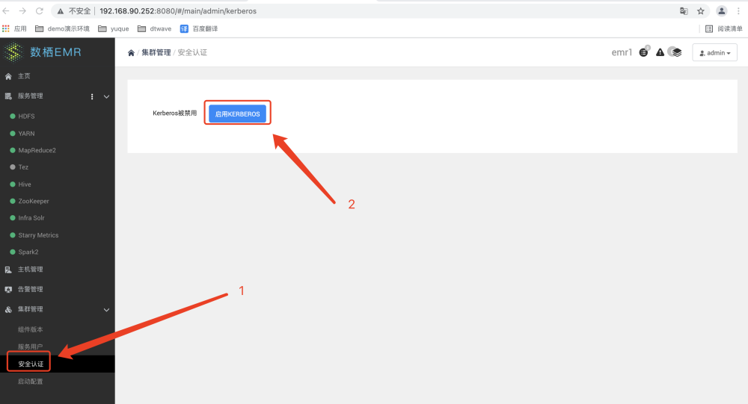

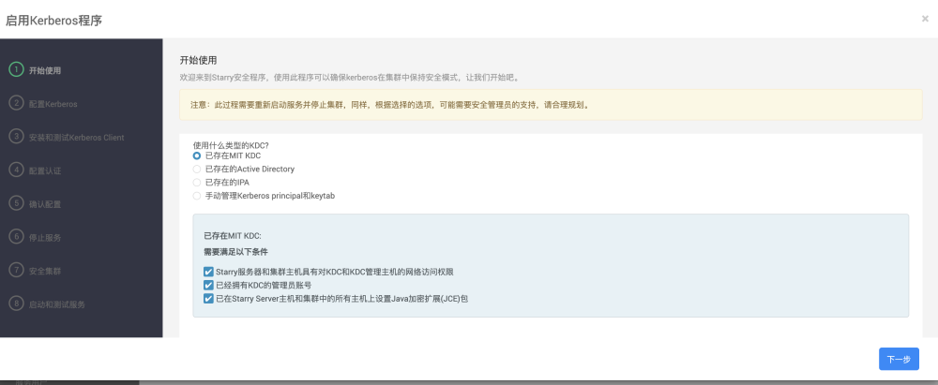

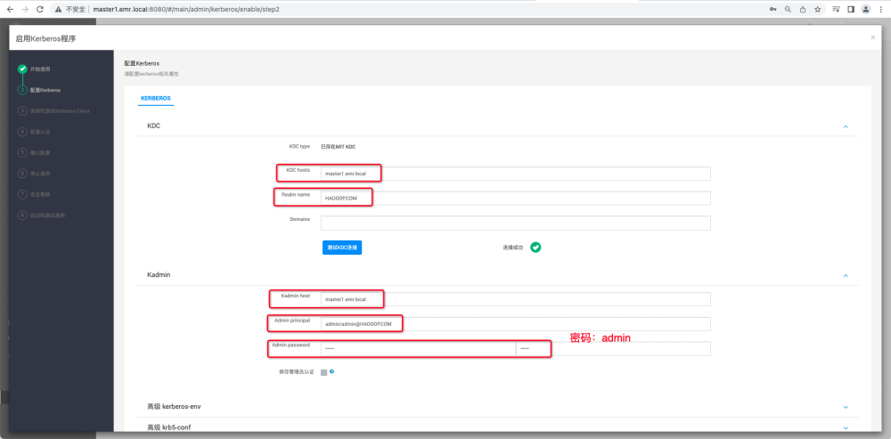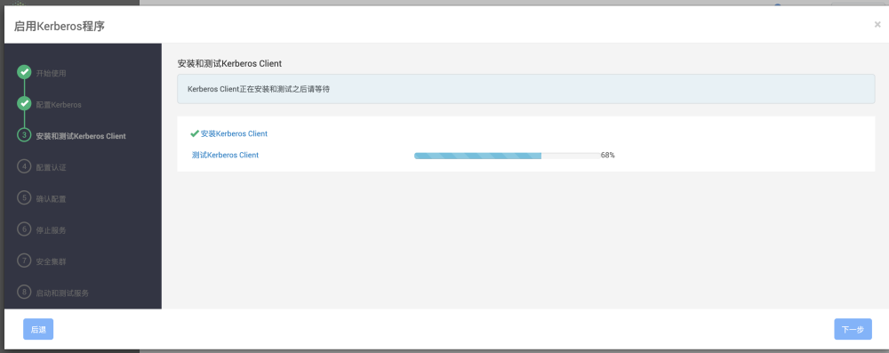

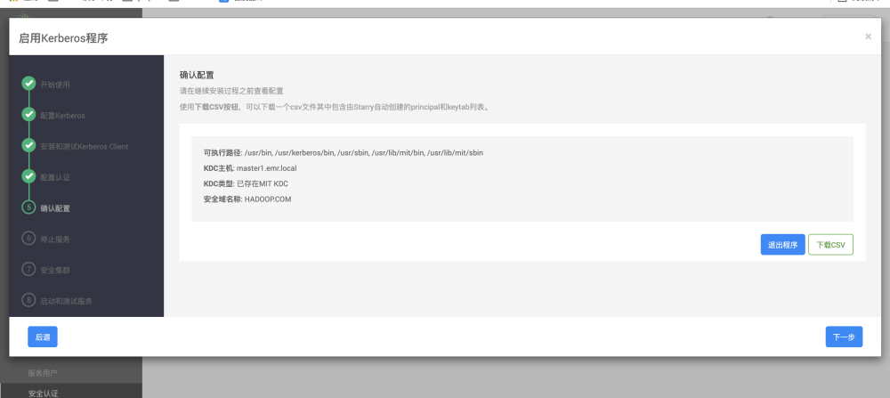

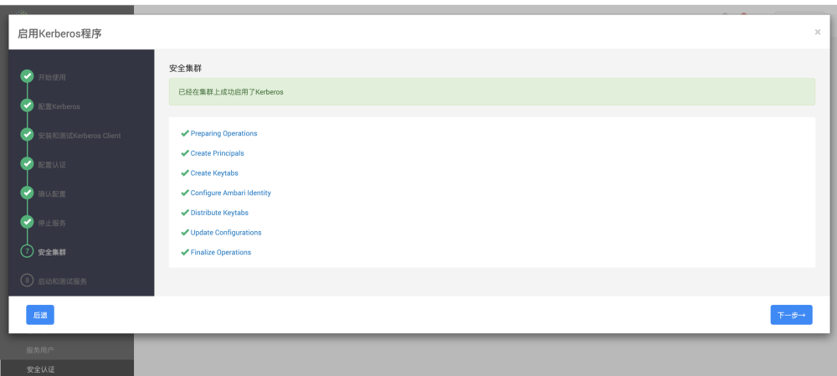

## EMR启动ranger

### 1.添加服务配置

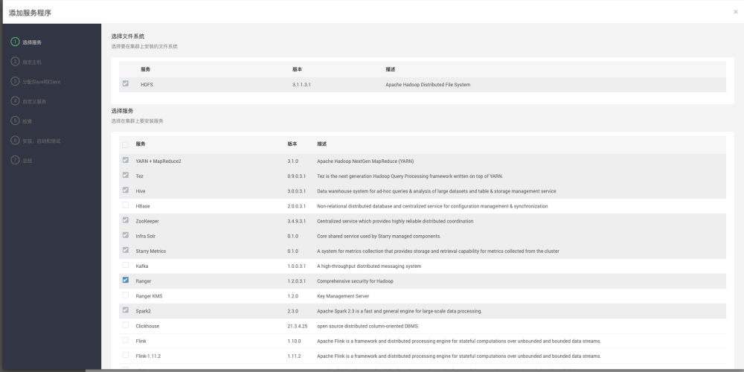

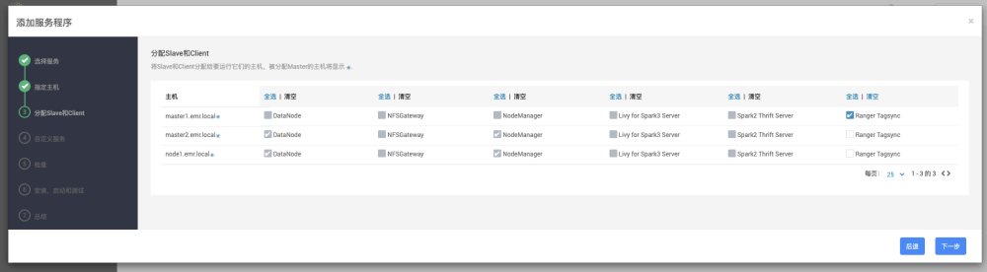

jdbc:mysql://192.168.90.112:3306/ranger?characterEncoding=utf8&useSSL=false

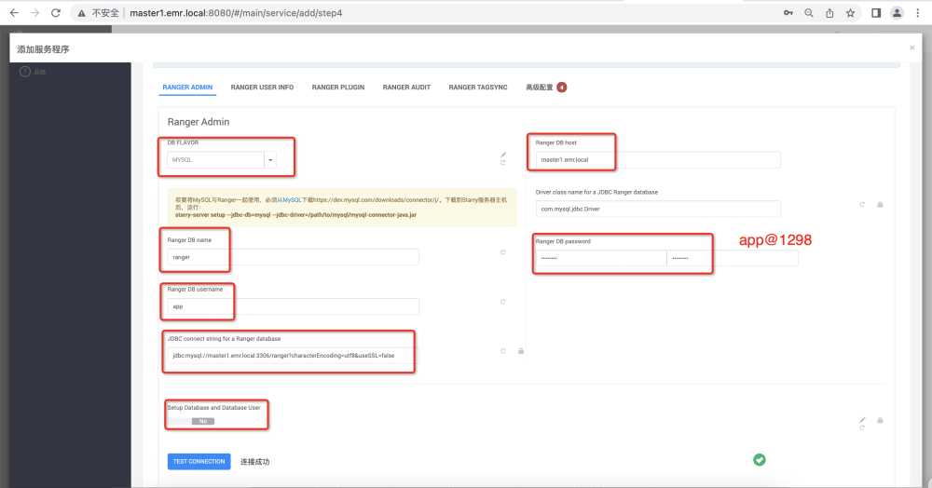

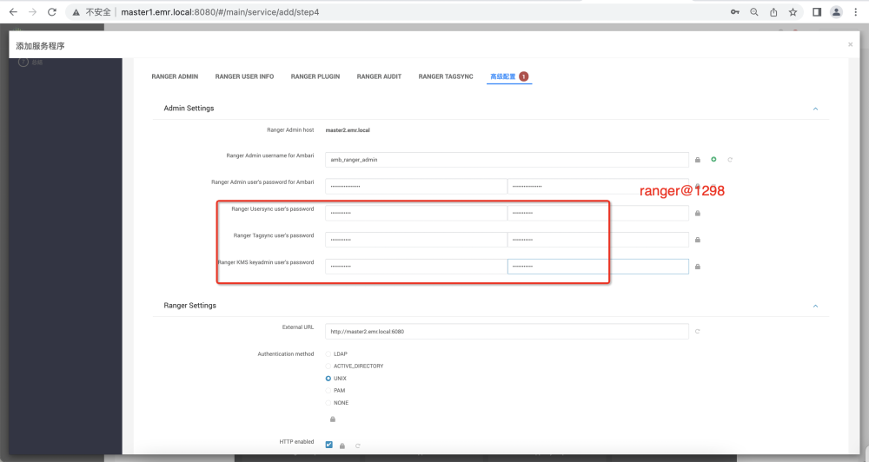

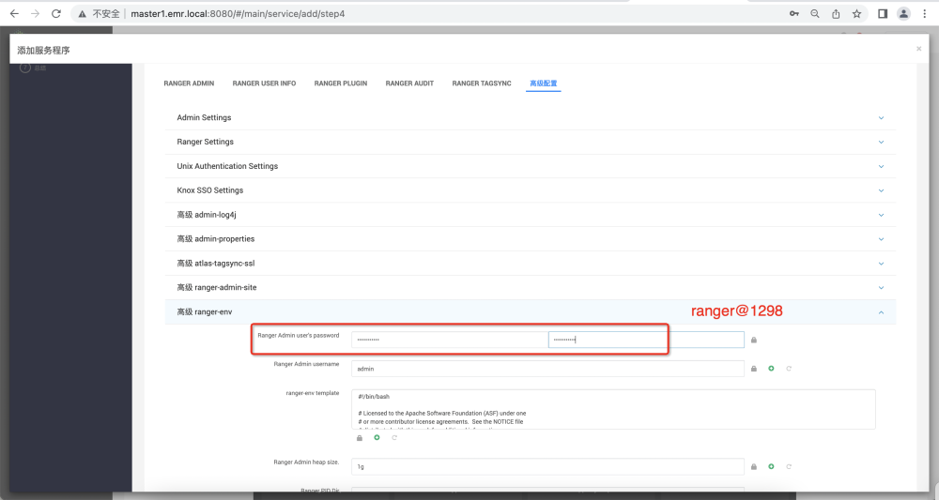

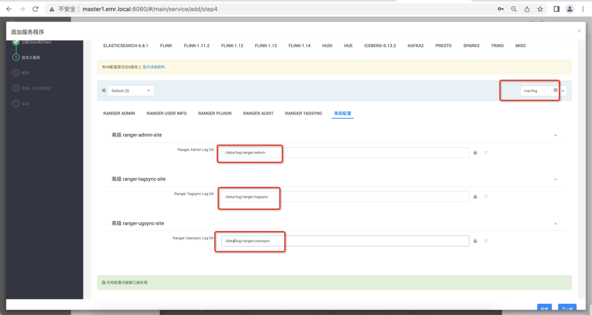

### 2.登录管理页面

点击右上侧连接：

[http://192.168.90.252:6080/index.html#!/policymanager/resource](http://192.168.90.128:6080/index.html#!/policymanager/resource)

输入用户名admin和密码Shuqi@1298

## 4.Ranger配置LDAP

#### hdfs配置修改，自定义core-site.xml中增加以下配置项

注意：修改hadoop.security.group.mapping.ldap.url配置地址

hadoop.security.group.mapping=org.apache.hadoop.security.LdapGroupsMapping  
hadoop.security.group.mapping.ldap.url=ldap://master1.emr.local:389  
hadoop.security.group.mapping.ldap.bind.password=Ldapadmin@1298  
hadoop.security.group.mapping.ldap.bind.user=uid=ldapadmin,ou=people,dc=hadoop,dc=com  
hadoop.security.group.mapping.ldap.baseou=ou=group,dc=hadoop,dc=com  
hadoop.security.group.mapping.ldap.userbase=ou=people,dc=hadoop,dc=com  
hadoop.security.group.mapping.ldap.groupbase=ou=group,dc=hadoop,dc=com  
hadoop.security.group.mapping.ldap.posix.attr.uid.name=uid  
hadoop.security.group.mapping.ldap.search.attr.group.name=cn  
hadoop.security.group.mapping.ldap.search.attr.member=memberUid  
hadoop.security.group.mapping.ldap.search.filter.group=(objectClass=posixGroup)  
hadoop.security.group.mapping.ldap.search.filter.user=(&(objectClass=posixAccount)(uid={0}))

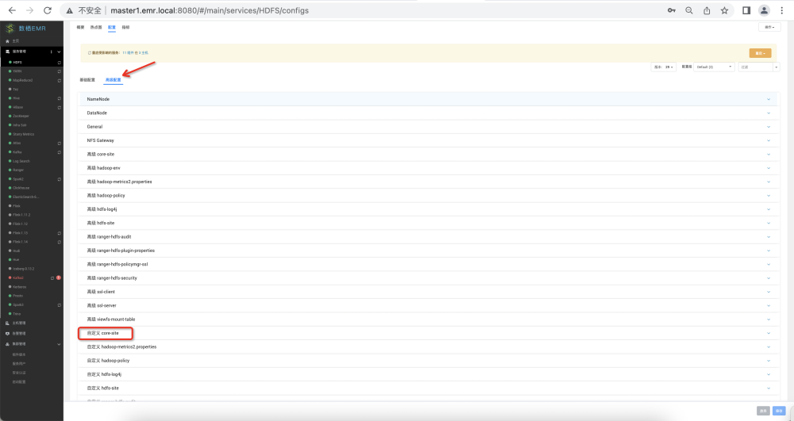

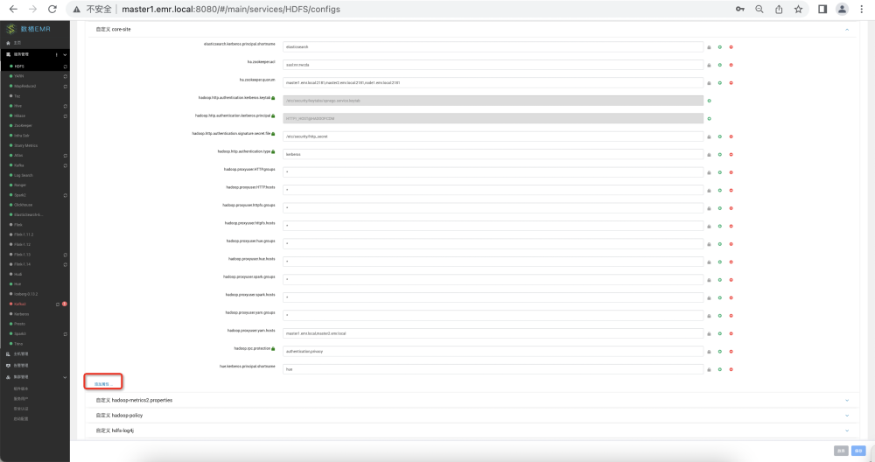

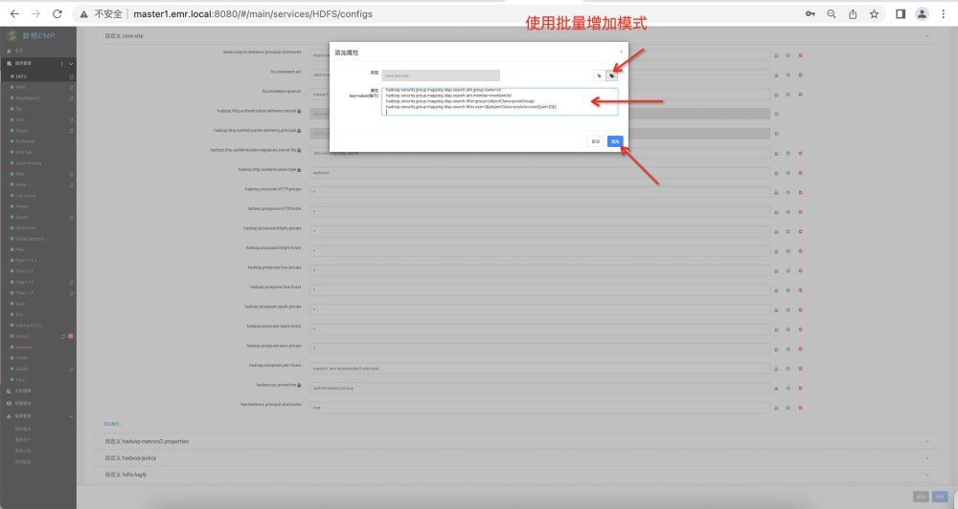

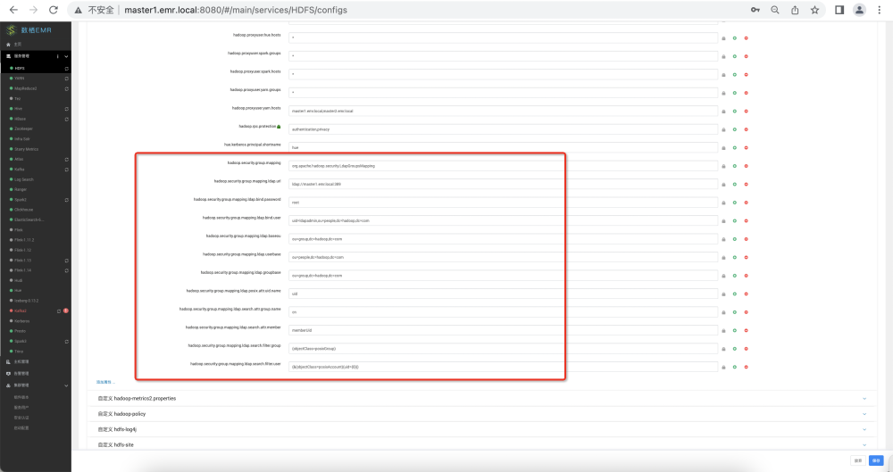

#### ranger配置common config

注意：修改ldap server地址

ldap://master1.emr.local:389  
uid=ldapadmin,ou=people,dc=hadoop,dc=com  
Ldapadmin@1298

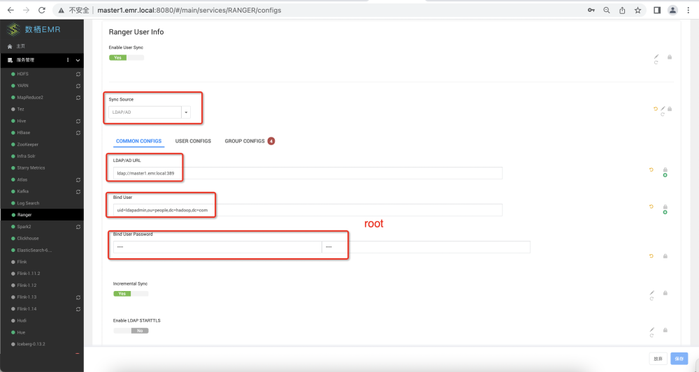

#### ranger配置user config

uid  
posixAccount  
dc=hadoop,dc=com  
cn=*  
sub  
gidNumber

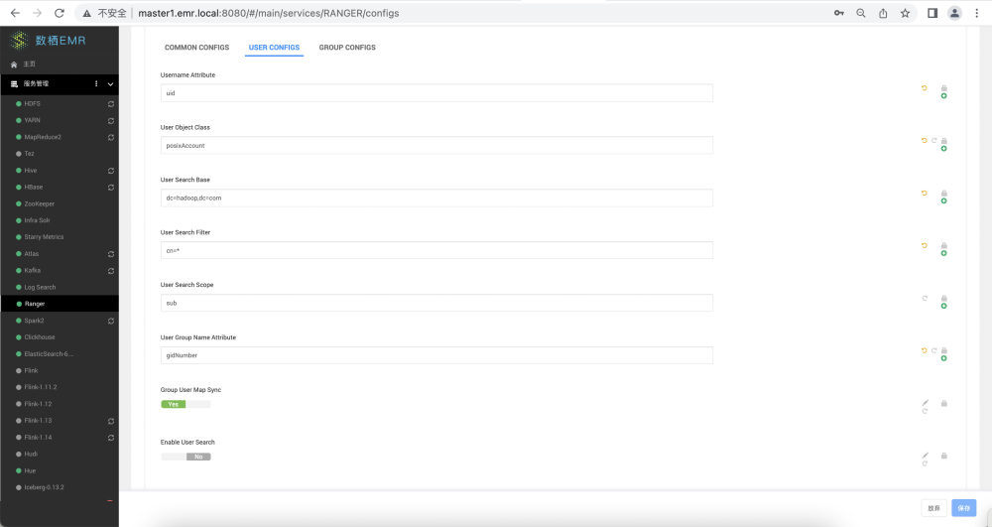

#### ranger配置group config

memberUid  
cn  
posixGroup  
dc=hadoop,dc=com  
cn=*

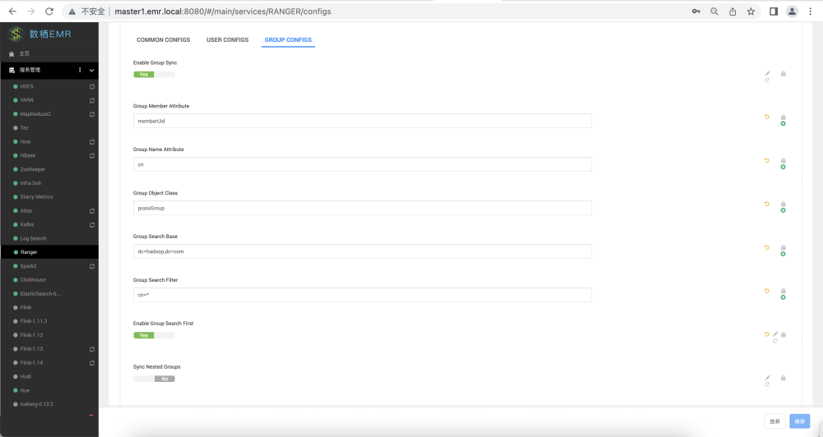

#### ranger plugins 配置

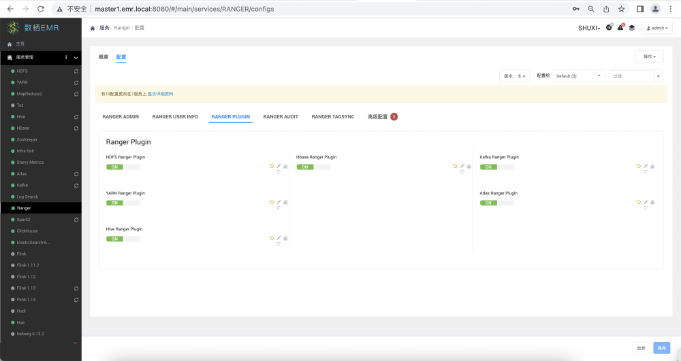

#### ranger高级配置

Xin@1298

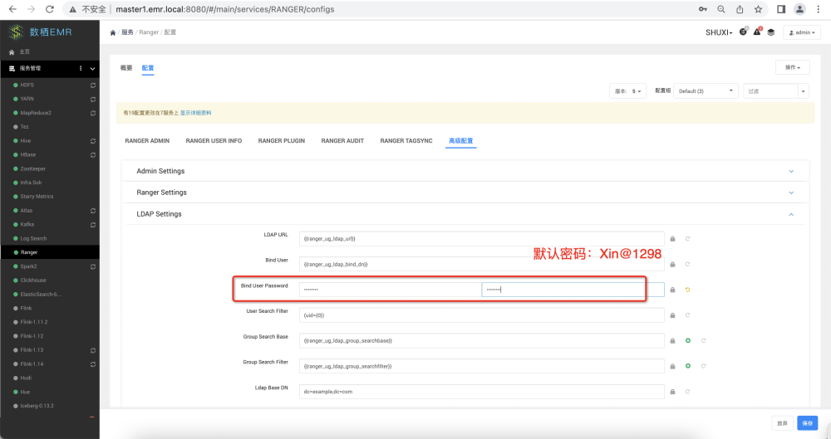

#### ranger配置保存

